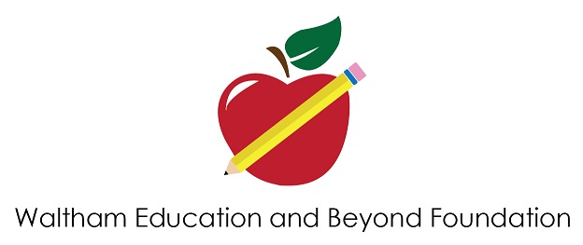

June 16, 2020

Dear Waltham Public Schools Educators,
With these uncertain times The Waltham Education & Beyond Foundation (WEBF) is aware of the challenges you are facing with virtual teaching and we want to help! The WEBF has decided to change our grant program for this year. We will be awarding 100 grants of $200 to Waltham educators to enhance your remote teaching capability for the 2020-2021 school year. Please submit for items that are not currently supplied by the school system for your work at home (i.e. whiteboard, document camera, etc.)
To be considered for a grant, please submit the following information to the WEBF Committee at WEBFgrants@gmail.com by July 10, 2020:

Full Name, Role, School(s)

What will you use the grant funding for?

How will the purchase(s) enhance your ability to teach remotely?

The mission of the Waltham Education & Beyond Foundation is to broaden community support to help achieve education excellence for all students in the Waltham Public Schools.
The purpose of the WEBF is to:
- Provide resources to support innovative ideas and projects that promote academic achievement, excitement in learning and instruction.
- Promote new educational ideas and initiatives.
- Fund projects that benefit the most number of students and teachers.

